SINGLE PARTICLE DIFFUSION TRACKING EXPERIMENT

LS2102
ARYA BASAK
23MS233

AIM:
In this experiment we will observe and track the Brownian motion of a single particle diffusing in an aqueous medium and then calculate the diffusion coefficient using that tracking.

METHODS:
Making of sample cell

- Making sample cell (2 per group)
- Putting in bead mix (use 30 ul) in the sample cell
- Focusing on sample using 100x oil immersion objective
- Checking diffusion of both kinds of beads
- Making video of beads diffusing for 1 min (1 video per group) using eyepiece-camera that will connect to your laptop.

Putting in bead mix (use 30 ul) in the sample cell
- Take a slide
- Cut two strips of parafilm, remove the paper and
- Place on top of the slide - parallel to each other with 1.5 cm space between them
- Take a 18/22 mm coverslip and place on top (above picture has wider coverslips)
- Gently press the sandwich
- Place on top of an Aluminium foil (AF) (folded double sheet) on a heater pressing the sandwich on top of the parafilms.
- Once parafilm has visibly melted, remove the AF, let it all cool before removing
- Introduce (20-50) ul of the bead mix at the free end of the sample-cell
- Make sure there is no fluid on top of the coverslip.
- Keep the sample-cell on the microscope with coverslip facing up.
- Place a drop of oil before focusing
- Be gentle with the focusing otherwise coverslip with break.
- To understand if you are looking at dirt on the camera/optics or sample, move the stage. Particles move = it is on the stage.
- May be easier to first find the edge of the parafilm and then gently move towards the solution.
CAPTURED SNAPSHOTS:
Snapshot from video 1
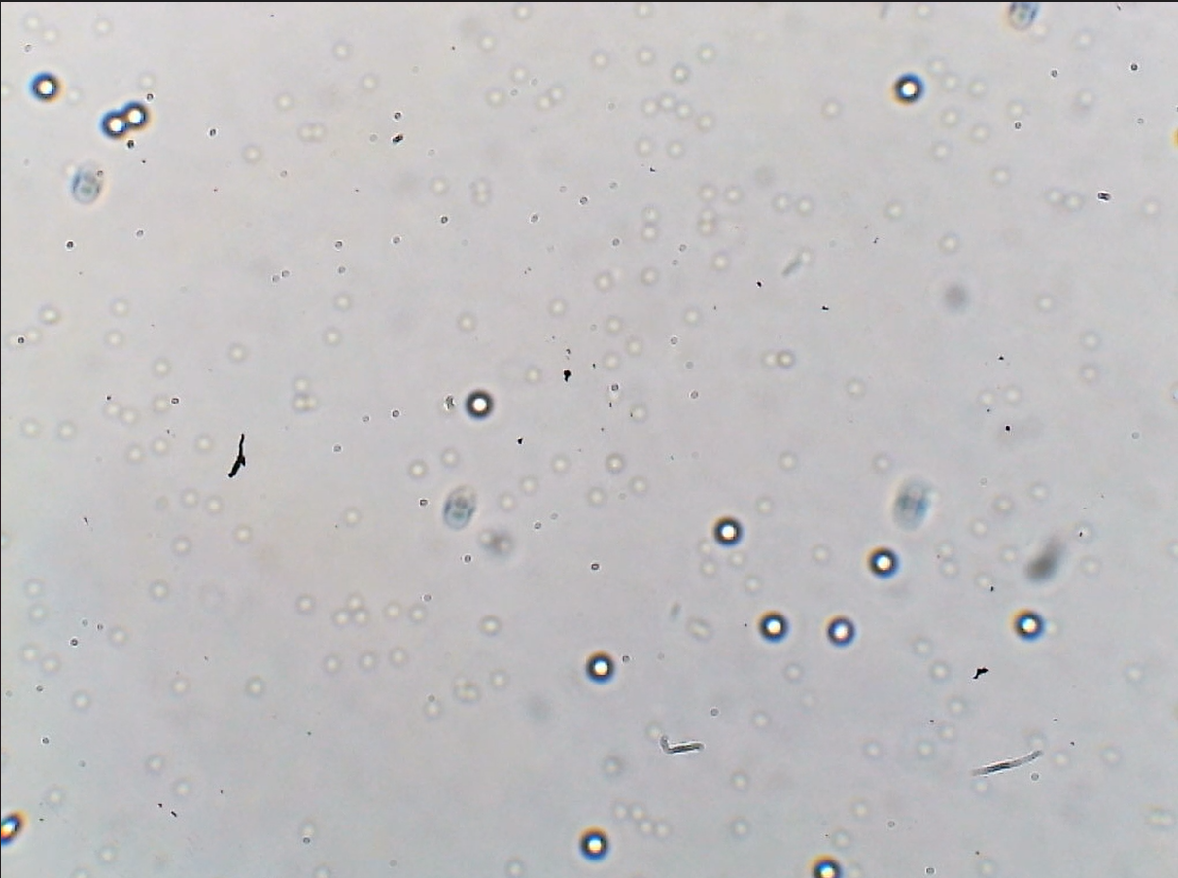

Snapshot from video 2
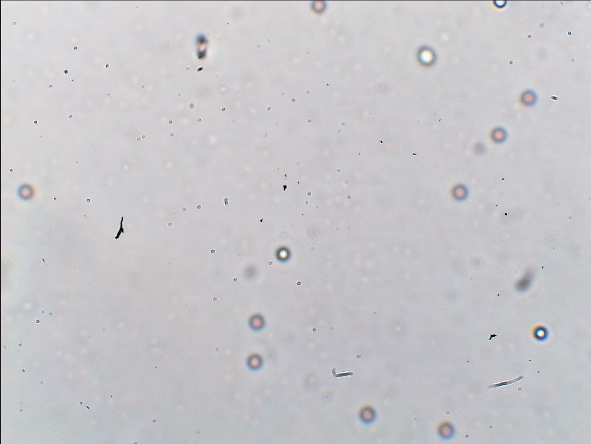

SOURCES OF ERROR:
- External Vibrations: Vibrations and motions from outside may affect the movement of the particle changing the result.
- Instrumental Error: There might be some kind of instrumental error unnoticed that can change the data taken.
- Calibration Error: One of the major step to analyze the data was to calculate the length of individual pixels. This step is one of primary sources of error that can badly affect the result.
- Tracking: Some error is also possible during tracking.

COMMENTS:
- We know, MSD(𝑡) = 2𝑑𝐷𝑡 where, D = diffusion coefficient and d = dimension.
- The slope of MSD vs 𝑡 graph represents the area covered by the particle per unit time.
- We can calculate diffusion coefficient D using the relation by plotting the graph and fitting the data into a linear curve. Note that, here
Slope = 2𝑑𝐷 ⇒ 𝐷 = slope/2d = slope/4 [here d = 2 as we can only track the x-y coordinates of the particle that is 2 dimensions]
- Significance of typical area covered by the bead per sec: It is basically the slope of MSD vs t graph by fitting the data points. It is a kind of velocity.

